Rewind — Project Overview
Oct 24, 2026 · @Ethan

Summary
Rewind is the register for our home video store: a movie room with DVD shelves, a concession bar and a counter where the family rents movies on movie night. It runs full screen on a Windows 11 mini PC and looks like a 1998 Windows register, with a barcode scanner, a customer pole display and a smart return box. The sign over the counter reads Rewind Video, and the motto is "Be kind, rewind."
It does four jobs:
- Checkout counter: member cards, store labels, concessions, fake cash with change to count back, due dates, and late fees the register invents now and then, since every DVD comes back the same night.
- Ask the Clerk: search, Staff Picks and seasonal shelves, a Can't Decide spinner, and a watch log with each person's star ratings.
- Intake: scan a new DVD, pick the movie from TMDB, and stick on a store label.
- Thrift-store catalog: a read-only phone app that works with no signal, so nobody buys a DVD we already own.
Rewind is a family heirloom, not a portfolio piece. One developer builds and maintains it, our family uses it for the next 20 years, and it costs $0 in licenses and usage. The register owns the data, so movie night never depends on Wi-Fi, the NAS or the internet.

Users, devices and environments
Four people use Rewind today, and the clerk role rotates each movie night. Everything runs on the register PC; the phones only read a copy of the catalog.
Item | Details
Users | Me, my wife, our son and our daughter, and someday the grandkids
Clerk | Whoever's turn it is this week; only the clerk uses the register
Register PC | Windows 11 mini PC at the counter, running Rewind full screen
Input | Keyboard, mouse and a USB barcode scanner in serial (COM) mode; no touchscreen
Counter hardware | STM32 Nucleo board driving a customer pole display and an IR return box
Phones | Three Android phones and one iPhone, with the read-only catalog installed from the browser
Desktop PC | Windows 11, where Rewind is developed in Visual Studio
NAS | Planned for HomeHub Phase 7; will receive backups and host the phone catalog
Collection | About 50 DVDs today and growing; DVDs only, no Blu-ray, VHS or games
My background is C# and .NET with Blazor, EF Core, WinForms and SQL Server, plus C and C++ as a hobby. Rewind uses the stack I build fastest with, so the time goes into the store instead of a new language.

Feature requirements
The first release covers the counter, intake, Ask the Clerk and Close Out; the counter hardware and the phone catalog follow.

The counter
- Looks like a 1998 Windows program: gray beveled buttons, navy title bars and pixel fonts, full screen.
- Runs on keyboard, mouse and barcode scanner. Function keys switch screens: F1 Checkout, F2 Return, F3 Ask the Clerk, F4 Intake, F5 Store Manager.
- Plays 90s sounds: a scan beep, a register chime, an error chord, a return-box chime and a spinner tick.
- Ask the clerk: the register is the only place to look anything up, like a real store.

Barcodes
- Every case gets a removable store label (Code 128, such as RV-00042), and every family member gets a membership card (MEM-001).
- Factory UPCs are scanned only when adding a DVD. Scanning one at checkout or return shows an error.
- A case with more than one movie, such as a box set or a double feature, asks "Which movie?" when it's scanned.

Checkout and concessions
- Scanning a member card can trigger a fake overdue alert for a movie they watched before, which adds a late fee to the bill.
- Late fees follow a shuffle bag: one overdue card in four per person, never twice in a row, and at most once per movie night.
- The clerk scans cases and rings up concessions (popcorn, fountain pop or SodaStream, candy) from buttons or a laminated barcode menu.
- Prices are flat 1990s prices, edited in the Store Manager.
- The clerk types the fake cash handed over, and the register shows the change and how to count it back in bills and coins.
- Rentals are due back the same night, and each item shows on the pole display as it's rung up.

Returns and the watch log
- A DVD dropped in the return box chimes and adds one to the "in the return box" count.
- The clerk scans each returned case to put it back on the shelf.
- The register records who watched, and each of them can give 1 to 5 stars or skip.

Ask the Clerk
- Search by title, actor, director, genre, year or rating.
- A Staff Picks shelf for each family member, plus seasonal shelves such as Halloween and Christmas. One movie can sit on several shelves.
- The Can't Decide spinner picks a movie that's on the shelf, filtered by genre, maximum runtime, maximum rating or shelf.
- The watch log shows who watched each movie, when, and everyone's stars.

Intake
- Scan the factory UPC: the register looks up the title, then shows matching TMDB movies with posters and years to pick from.
- A second edition of a movie we already own joins that movie instead of creating a new one.
- If TMDB has no match, the clerk enters the movie by hand.
- To finish, peel the next store label, stick it on the case and scan it.

Close Out
- Ends the business day: saves a timestamped backup, writes the phone catalog, and copies both to a USB drive now and the NAS later.
- Never fails because of the network. A missed NAS copy waits for the next Close Out, and the screen shows when the last one landed.

Phone catalog
- Search the collection by title, or scan a DVD's barcode with the camera, with no signal needed in the store.
- A known barcode shows "Already owned"; an unknown one says "Not this edition. Search by title."
- Holds movies only: no names, prices or watch history.

Access
- The register works with no internet; only intake and the TMDB refresh need it.
- The phone catalog refreshes whenever the phone can reach the NAS, then works offline.

Technology stack
Rewind is one C# program on .NET 10: a WinForms window that hosts Blazor components styled with 98.css, over a SQLite database on the register itself. Every piece is free, and each was picked as the fastest thing for me to build that still does the job well.
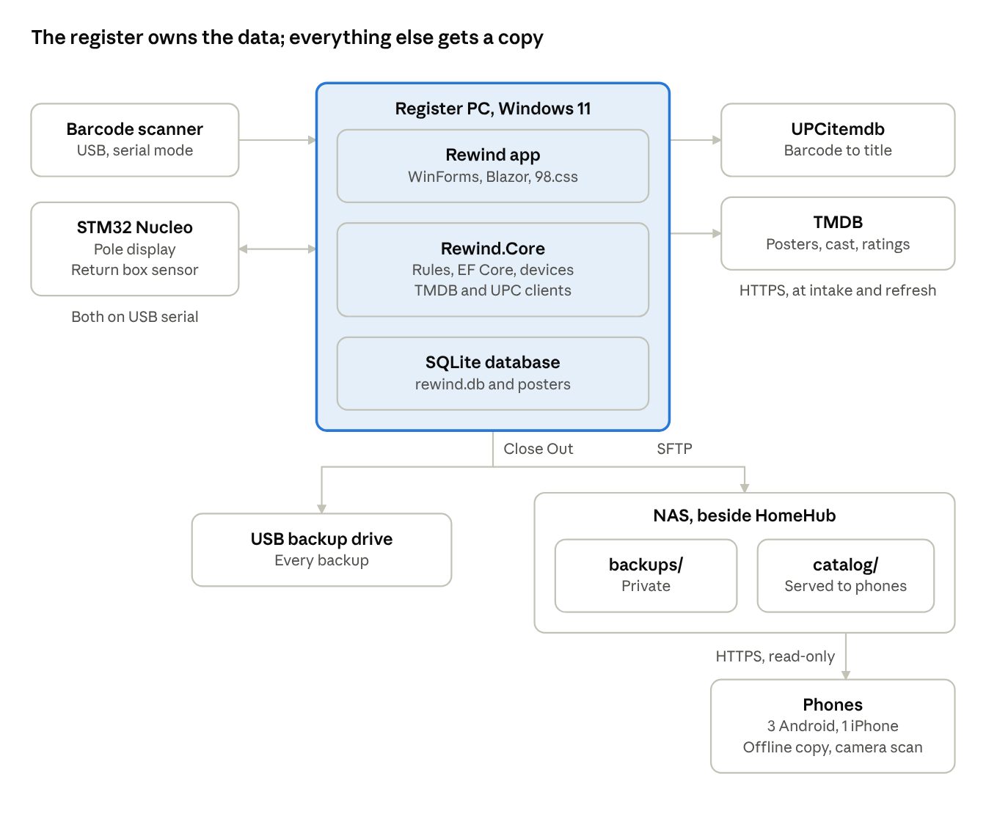
Rewind architecture · register, devices, internet, NAS and phones
Movie night needs only the register. The internet is used at intake and for refreshes, and the NAS and the phones only ever receive copies.
Layer | Choice | Why
Register app | C# on .NET 10 (LTS): a WinForms window hosting Blazor through BlazorWebView | One program built with the skills I use daily; components run in-process with direct access to the database, serial ports and network
UI | Razor components styled with 98.css | Windows 98 windows, title bars, buttons and pixel fonts with no custom drawing
Web view | WebView2, preinstalled on Windows 11 | Draws the components; browser shortcuts, dev tools and outside links are turned off
Database | SQLite in WAL mode, through EF Core 10 | One file on the register's SSD; EF migrations rebuild tables when SQLite can't alter them in place
Devices | System.IO.Ports | Reads the scanner and talks to the STM32 over USB serial
Metadata | HttpClient to the UPCitemdb free plan and the TMDB API | Barcode to title, then posters, cast, runtime and US rating; both free for our use
Sound | NAudio | Plays several WAV files at once from C#, outside the browser's autoplay rules
Labels | ZXing.Net draws Code 128 as SVG, printed from WebView2 | Exact label-sheet layout in CSS, on any Windows printer
NAS copy | SSH.NET over SFTP to an upload-only account | Windows has no rsync, and the account can't open a shell
Logging | Serilog with a rolling log file | A record of what happened on movie night
Firmware | C on an STM32 Nucleo with the HAL, configured in STM32CubeMX | Pole display over I2C, break beam on an interrupt, serial through the ST-LINK
Phone catalog | Static PWA: HTML, CSS and JavaScript, a service worker, barcode-detector | Works offline, needs no server code, and has no build step to rot
Tests | xUnit, bUnit, FakeTimeProvider, a real SQLite database, plain C tests for the firmware parser | See Testing strategy
CI | GitHub Actions | Builds and tests every push
Version notes: .NET 10 is the current LTS release, supported through November 2028, so Rewind stays on it when .NET 11 ships this November. The BlazorWebView package for WinForms targets net10.0-windows and is MIT-licensed. STM32CubeIDE 2.0 no longer includes STM32CubeMX, so the board is configured in standalone CubeMX and the generated project is imported into the IDE.

Data model
A case is the physical thing on the shelf and a movie is the film, so one case can hold several movies and one movie can sit in several cases. Everything else hangs off those two, and the watch log is protected so nothing can delete it.
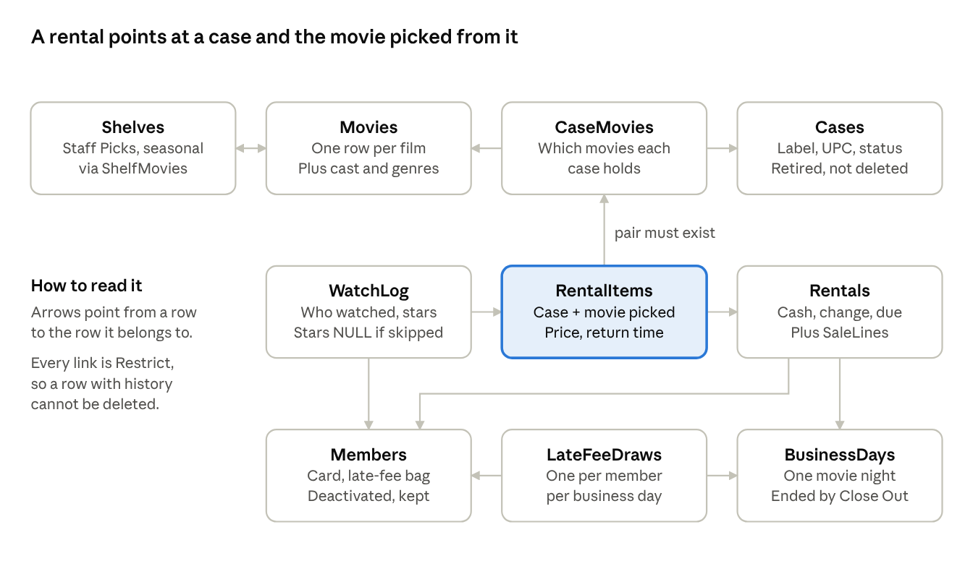
Rewind data model · the ten main tables and how they link
RentalItems points at a case and movie pair in CaseMovies, so a box-set pick can only be a movie that's really in that case.
Table | Holds | Key rules
Movies | One row per film: TMDB ID, title, year, runtime, US rating, director, overview, poster file, when TMDB was last fetched | TmdbId is unique; unknown values are NULL
MovieCast, Genres, MovieGenres | Top-billed cast and genres from TMDB | Replaced when the movie is refreshed
Cases | One row per physical case: store label, factory UPC, status | Label unique; UPC indexed but not unique; status is On shelf, Checked out or Retired
CaseMovies | Which movies each case holds | One row for a normal DVD, several for a box set or double feature
Members | Family members, card barcode, late-fee bag, active flag | Card barcode unique; deactivated, never deleted
Shelves, ShelfMovies | Staff Picks and seasonal shelves | A movie can sit on many shelves
BusinessDays | Each movie night, from the first sale to Close Out, with backup and copy times | Only one is open at a time
Rentals | One checkout: member, business day, due date, total, cash tendered, change | All money in cents
RentalItems | Each case rented, the movie picked from it, its price and return time | Its case and movie pair must exist in CaseMovies
SaleLines | Concessions and late fees on a rental | Price copied at the time of sale
LateFeeDraws | Each shuffle-bag draw: member, business day, outcome, flavor movie | One draw per member per business day
WatchLog | Who watched each rented movie, and their stars | One row per person per rental item; stars are NULL when skipped
ConcessionItems | Snacks and drinks with their barcode and price | Retired with an active flag
StoreSettings | Rental price, late fee amount, store name | One row, edited in the Store Manager
UpcLookups | Cached UPCitemdb answers | Saves the free plan's 100 requests a day
Rules that hold everywhere:
- Money is whole cents in integer columns: prices, totals, cash and change.
- Unknown is NULL. A missing runtime, rating or star count is never 0, "NR" or an empty string.
- History is never deleted. Cases retire, members deactivate, and every foreign key is Restrict, so nothing cascades into the watch log.
- TMDB owns only its tables. Its data lives in Movies, MovieCast, Genres and MovieGenres; anything the family adds lives elsewhere, so a refresh can't overwrite it.
- Times are stored in UTC and shown in local time. A movie night is a BusinessDay row, not a calendar date, so a night that runs past midnight is still one night.
- Primary keys are integers. The human-facing IDs are the store labels and member cards, kept in their own unique columns.

Barcodes and intake
Rewind reads four kinds of barcode, and the prefix alone tells it which one arrived.
Scanned | Looks like | Accepted on | Does
Store label | RV- and five digits (RV-00042) | Checkout, Return, Intake | Identifies one physical case
Member card | MEM- and three digits (MEM-001) | Checkout | Starts a rental and draws a late-fee card
Concession | CON- and a word (CON-POPCORN) | Checkout | Adds that item to the bill
Factory UPC or EAN | 12 or 13 digits | Intake only | Looks up the title; anywhere else it plays the error chord and shows "Please scan the Rewind Video label."
Labels are Code 128 on removable label sheets, printed from the Store Manager in numbered batches. A UPC names an edition, not a movie: a box set has one UPC for several movies, and each edition of a movie has its own UPC. So Rewind never checks out by UPC, but it saves each case's UPC for the phone catalog, as 12 or 13 digits: a 13-digit EAN that starts with 0 is the same product as a 12-digit UPC-A, so it's saved in that form.
Intake, on F4:
- Scan the factory UPC. Rewind checks its UPC cache, then asks the UPCitemdb free plan for the product title.
- Rewind trims words like "DVD" and "Widescreen" from the title and searches TMDB.
- The clerk picks the right movie by poster, year and overview, since three different movies are called Halloween.
- If that TMDB movie is already in the collection, the new case joins it. Otherwise Rewind saves the movie with its cast, genres, US rating and poster.
- With no UPC, no title found or no TMDB match, the clerk types the title, or enters the whole movie by hand.
- For a box set or double feature, the clerk adds each movie in the case.
- The clerk sticks on the next store label and scans it, which saves the case as On shelf.
The UPCitemdb free plan needs no signup and allows 100 requests a day at about 6 lookups a minute, so a big thrift-store haul is entered at a steady pace. TMDB is free for non-commercial use with credit in an About or Credits screen, so Help > About shows TMDB's logo and notice. TMDB's terms cap caching at six months, so Rewind refetches any movie older than five months whenever it's online.

Checkout, returns and late fees
A movie night is one business day: it opens with the first scan and ends when the clerk runs Close Out. Every rental, late-fee draw and backup belongs to one, which keeps "once a night" rules simple.
Checkout, on F1:
- Scan the member card, and Rewind draws that member's late-fee card.
- An Overdue card pops up a flashing OVERDUE RENTAL alert naming a movie they watched before. It plays the error chord, flashes the pole display and adds the late fee to the bill.
- Scan each case. A multi-movie case asks which movie is going home.
- Add concessions with the buttons, or by scanning the laminated concession card.
- Type the cash tendered. Rewind shows the change and how to count it back, then plays the register chime.
- Rewind saves the rental, its items, concessions and any late fee in one transaction, and marks each case Checked out.
Return, on F2:
- A drop in the return box adds one to the count in the status bar.
- The clerk scans each case. It goes back On shelf with its return time, and the count drops by one.
- Rewind asks who watched and each person's stars, and skipping is fine.
- The return-box count resets at Close Out.
The shuffle bag keeps late fees fair for kids:
- Each member has a bag of four cards, one Overdue and three Clear. Each draw takes the next card, and an empty bag is reshuffled.
- If the last card drawn was Overdue, the new bag can't start with Overdue, so nobody is hit twice in a row.
- A member draws at most once per business day, so rescanning a card can't fish for a clean result. A unique index on member and business day enforces it.
- The flavor movie comes from that member's watch history, or from the whole collection if they have none yet.
- Late fees live only in SaleLines and LateFeeDraws, so the watch log stays true.
Starting prices, all editable in the Store Manager and stored in cents:
Item | Price
Rental, per movie | $2.00
Late fee | $1.00
Popcorn | $1.00
Fountain pop or SodaStream | $0.75
Candy | $0.50
Rentals are due back the same night, so the screen and the pole display say "Due back tonight." Change is broken into the largest bills and coins first, from $20 down to pennies, so the clerk can count it back.

Close Out and backups
Close Out ends the business day and makes that night's backup, and it always finishes. A copy that can't happen is reported on screen and tried again at the next Close Out.
The clerk presses Close Out Register, and Rewind:
- Closes the open business day and resets the return-box count.
- Saves a backup with SQLite's online backup API, such as backups\rewind-2026-10-23-2215.db. The time in the name means a second Close Out the same night never collides.
- Writes catalog.json and any new poster thumbnails for the phone catalog.
- Copies the backup to the USB backup drive, which it finds by a marker file, so it never writes to a random flash drive.
- Uploads the backup and the catalog to the NAS over SFTP, into separate folders. Only the catalog folder is served to phones.
- Shows a Windows 98 checklist of what worked, plus the date of the last NAS copy, in red when it's more than two weeks old.
The register keeps its newest 30 backups, while the USB drive and the NAS keep every one; a year of weekly backups is small. Rewind also backs up before it applies a database migration. Never copy rewind.db itself while Rewind runs: in WAL mode, recent changes sit in a separate file, so only the backup API makes a safe copy.
To restore, which the README spells out step by step:
- Close Rewind.
- Delete rewind.db-wal and rewind.db-shm from the data folder.
- Copy the chosen backup over rewind.db and start Rewind. Missing posters download again from TMDB.

Counter hardware
One STM32 Nucleo board runs both counter gadgets and talks to the register through its built-in ST-LINK USB serial port, so one cable carries everything.
- Customer pole display: a 20×2 character LCD on a PCF8574 I2C backpack, in a housing facing the customer. It shows each item and price as it's rung up, the total, the change, alerts, and WELCOME TO REWIND VIDEO when idle.
- Smart return box: an IR break-beam sensor across the slot, on an interrupt pin. A drop chirps a buzzer, blinks an LED and tells the register.
Wiring, by the Nucleo-64's Arduino header labels; each board's user manual maps them to chip pins:
Part | Header pin | Notes
LCD backpack VCC, GND | 5V, GND | Its pull-ups then sit at 5 V, so check that your I2C pins are 5 V tolerant (FT)
LCD backpack SDA, SCL | D14, D15 | I2C1 on most Nucleo-64 boards; address 0x27, or 0x3F on PCF8574A backpacks
Break-beam receiver | D2 | Input with pull-up, interrupt on the edge where the beam breaks
Break-beam emitter | 5V, GND | Mounted across the slot from the receiver
Buzzer | D3 | An active buzzer is one pin; a passive one needs timer PWM but can play a tune
LED | D7 | Through a current-limiting resistor
The protocol is plain ASCII at 115200 baud, 8N1: one message per line, fields split by a pipe.
Direction | Message | Meaning
Register to board | PING | Are you there?
Board to register | PONG | Yes
Board to register | READY|rewind-counter|1.0 | Sent once at boot, with the firmware version
Register to board | DISP|line one|line two | Show two lines on the pole display
Register to board | ALERT|line one|line two | Blink the display three times, then show two lines
Board to register | EVENT|DROP | A DVD broke the beam
Board to register | ERR|UNKNOWN | It didn't understand a line
The register pads or trims each line to 20 characters and sends plain ASCII, so the firmware only prints. Rewind finds the board by its USB vendor ID, 0483 for STMicroelectronics, never by COM number. If the board is unplugged, the status bar says so and Rewind retries every few seconds, while movie night carries on without the display.

Phone catalog
The phone catalog answers one question in a thrift store, "Do we already own this?", and it works with no signal. It's a static web app on the NAS that each phone installs from the browser and keeps a copy of.
- What it holds: catalog.json and small poster thumbnails from the last Close Out: titles, years, genres, runtimes, ratings and the UPCs of the cases we own. No names, prices or watch history.
- How it stays offline: a service worker caches the app, the catalog and the thumbnails. The phone refreshes them whenever it can reach the NAS and shows the catalog's date, so you know how fresh it is.
- Search: type part of a title, and the search runs on the phone itself.
- Camera scan: a known UPC shows "Already owned: Jaws (1975)." An unknown one says "Not this edition. Search by title," and puts the cursor in the search box.
- iPhone support: Safari has kept its built-in barcode reader behind a feature flag, so the barcode-detector library reads barcodes with WebAssembly instead. Its .wasm file is served from the NAS and cached, because the library's default CDN fails offline.
- Reaching the NAS: installing the app needs HTTPS, which comes from the remote access HomeHub picks in its step 7.2. With Tailscale, the catalog stays private to our own devices.
To install, Android phones open the address in Chrome and choose Install app; the iPhone opens it in Safari and taps Share, then Add to Home Screen.

The register PC
The register is a Windows 11 mini PC set up like an appliance: it boots straight into Rewind and gets itself back up after a crash or a power cut.
- Account: a standard local account named Counter signs in automatically through Sysinternals Autologon. Admin work uses a separate account.
- Start and recovery: a small launcher script runs at sign-in and relaunches Rewind whenever it exits, unless the Store Manager's Shut Down button closed it.
- Full screen: Rewind's window has no border and fills the screen, so Windows 11's frame never shows. Alt+F4 is ignored.
- WebView2 locked down: browser shortcuts, dev tools, the right-click menu, zoom and outside links are all off, so F5 can't reload the register.
- Quiet on movie night: Do Not Disturb is on, active hours cover the evening, and updates can be paused for up to five weeks around a busy stretch.
- Power: the PC never sleeps. The screen can turn off and wakes on a key press.
- Folders: everything lives under C:\Rewind: app (one folder per version), data (the database and posters), backups, logs and keys.
- Installs: each release is a self-contained publish, with the .NET runtime inside, copied to its own app folder. The launcher runs the newest, and the previous version stays for a quick rollback.
- Display: use a whole-number WebView2 zoom so the pixel fonts stay sharp, 1× on a 1024×768 monitor or 2× on a 1080p one. A thrift-store 4:3 monitor finishes the look.

Solution layout
Three .NET projects keep the rules apart from the screens and the screens apart from Windows, so the UI is a thin layer that could move to another host later.
Rewind/
├── docs/
│ ├── adr/ # Architecture Decision Records
│ └── handbook/ # One-page clerk handbook for the counter
├── src/
│ ├── Rewind.Core/ # Rules, use cases, EF Core + SQLite, serial devices, TMDB and UPC clients
│ ├── Rewind.UI/ # Razor class library: screens, dialogs, 98.css, keyboard script
│ └── Rewind.Register/ # WinForms host: BlazorWebView, WebView2 settings, NAudio, device discovery
├── phone/ # Static PWA: index.html, app.js, sw.js, vendor/
├── firmware/
│ └── rewind-counter/ # STM32CubeMX + STM32CubeIDE project in C
├── tools/
│ └── launcher.ps1 # Starts Rewind at sign-in and relaunches it
└── tests/
├── Rewind.Core.Tests/ # xUnit: rules, and data against a real SQLite file
├── Rewind.UI.Tests/ # bUnit component tests
└── firmware/ # Host-side C tests for the line parser
Rewind.Core and Rewind.UI target plain net10.0 and build on any OS. Only Rewind.Register targets net10.0-windows, so Windows-only pieces such as NAudio and the WebView2 settings stay in one place.

Testing strategy
Tests aim at what would spoil a movie night or lose history: money, the late-fee rules, the data rules and the device protocol. They run on every push.
Level | Tools | Key cases
Rules | xUnit, FakeTimeProvider, a seeded Random | Change and count-back; the shuffle bag never hits twice in a row and draws once per business day; barcode types; a 13-digit EAN that starts with 0 stored as its 12-digit UPC-A; the spinner skips unknown runtimes and ratings when a cap is set
Data | xUnit, a real SQLite file with migrations applied | Deleting a movie with history is refused; a box-set pick must be a movie in that case; labels are unique; a sale line keeps its price after a price change; a TMDB refresh leaves shelves and ratings alone
Screens | bUnit | A factory UPC at checkout shows the error dialog; totals and change; the Which movie? picker
Firmware | Plain C tests built with gcc | The line parser handles an overlong line, an unknown command and CR+LF endings
Movie night | A printed checklist | A full checkout and return on the real counter, the scanner unplugged mid-screen and plugged back in, a Close Out with the NAS unplugged, and a restore onto a spare PC

Roadmap
The first goal is a playable movie night on any Windows PC, with every DVD labeled and cataloged; the counter hardware and the phone catalog come after. The Build Plan breaks each phase into steps.

Phase 1: The register shell
- ☐ Solution, Blazor in WinForms with 98.css, SQLite, sounds, the scanner and CI

Phase 2: Intake
- ☐ UPCitemdb and TMDB lookups, the intake screen, printed labels and member cards
- ☐ Every DVD we own cataloged and labeled

Phase 3: Movie night
- ☐ Members, prices, checkout with late fees, returns with ratings, and Close Out to USB
- ☐ Proof: one full movie night on the register, with no paper

Phase 4: Ask the Clerk
- ☐ Search, Staff Picks and seasonal shelves, the Can't Decide spinner, the watch log, the TMDB refresh and Help > About

Phase 5: Counter hardware
- ☐ Pole display and return box firmware, wired to the register

Phase 6: The register PC
- ☐ The mini PC set up as an appliance, whenever it arrives

Phase 7: NAS and phone catalog
- ☐ Close Out copies to the NAS, and the offline phone catalog, once HomeHub's NAS is running
Later: a Now Showing marquee in the movie room, a vacuum fluorescent pole display, and a Linux host if Windows ever becomes a problem.

Open decisions
Eight choices are still open; none of them blocks Phases 1 to 3.
- ☐ Pole display: a 20×2 LCD (the classic size), a 20×4 LCD, or a vacuum fluorescent display.
- ☐ Register monitor: a 4:3 monitor at 1024×768, or a widescreen at 2× zoom.
- ☐ Rental period: due back tonight, or a two-night rental for flavor.
- ☐ Late-fee odds and amount: one Overdue card in four at $1.00 to start.
- ☐ Seasonal shelves: which ones, and the dates each one shows up.
- ☐ Remote access for the phone catalog: Tailscale or Cloudflare Tunnel, decided with HomeHub's step 7.2.
- ☐ Repository: private, which keeps family names and any Windows sounds out of public view, or public.
- ☐ The mini PC's Windows 11 edition: Pro can defer updates by policy, while Home can only pause them.

Licensing and cost watch-list
Everything Rewind uses is free for a family project; the two APIs have usage limits, and the Windows sounds aren't ours to share.
Item | Status | Decision
TMDB API | Free for non-commercial use with credit in an About or Credits screen; caching limited to six months | TMDB logo and notice in Help > About; refetch movies older than five months
UPCitemdb | Free plan: no signup, 100 requests a day, 6 lookups a minute | Cache every answer; pace big intakes
Windows 11 | Comes with the mini PC | No separate license
BlazorWebView for WinForms | MIT | Use
98.css | MIT | Copy its files into the repo
NAudio | MIT | Use
SSH.NET | MIT | Use
ZXing.Net | Apache 2.0 | Use
barcode-detector | MIT | Copy its files and its .wasm into the phone app
html5-qrcode | Unmaintained; no release since April 2023 | Not used
Windows 95 and 98 sounds | Microsoft's recordings | Keep them out of the repo; free or homemade sounds work too
STM32CubeIDE and STM32CubeMX | Free from ST | Use
Tailscale | Free personal plan, up to six users | Use HomeHub's choice from step 7.2

Built to last
Rewind is meant to outlive the PC it runs on, so the data and the know-how get the protection, not the program.
- The database is the heirloom. The watch log, ratings and Staff Picks live in one SQLite file that any future tool can open.
- Backups live in three places: the register, a USB drive, and the NAS, which HomeHub backs up off-site.
- Releases carry their own runtime. Each one is a self-contained folder, so it still runs years later without installing .NET.
- The README covers the hard days: how to run, test, restore a backup and replace the register PC. A one-page clerk handbook sits at the counter.
- ADRs record the why. Each real decision gets one in docs/adr, so a future developer, maybe a grandkid, knows why things are the way they are.
- Windows is replaceable. Only Rewind.Register is Windows-specific, so the screens could move to a Blazor Server host on Linux without a rewrite.

Sources
The version, licensing and API facts above come from these pages, checked on October 20, 2026.
- .NET Support Policy (.NET 10 supported through November 14, 2028)
- Microsoft.AspNetCore.Components.WebView.WindowsForms 10.0.90 (NuGet)
- Build a Windows Forms Blazor app (Microsoft Learn)
- SQLite database provider limitations (EF Core docs)
- Cascade delete (EF Core docs)
- Microsoft.Data.Sqlite connection strings
- TMDB API FAQ (free non-commercial use, attribution)
- TMDB rate limits and caching (APIs.io summary of TMDB's API terms, whose page blocks automated reading)
- UPCitemdb plan comparison
- 98.css (GitHub)
- barcode-detector (GitHub)
- WebKit bug 281848: Shape Detection API doesn't work on iOS
- Quagga2 vs. html5-qrcode (Scanbot)
- NAudio releases (GitHub)
- SSH.NET (GitHub)
- ZXing.Net package details (DepScope)
- What's new in STM32CubeIDE 2.0.0 (ST Community)
- Tailscale plans

